Five Minute Traffic Trick

How To Get Instant Traffic and Instant High PR Links To Your Squidoo Lenses and HubPages
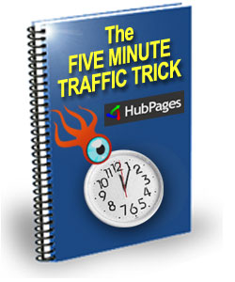

This method of generating traffic is very easy to implement yet very few people know about it. It's very powerful and if you use it with a great affiliate product or any product that you're selling. It has the potential of making some money quickly. I've been using this method in just under a year now on Squidoo. When I discovered HubPages several months ago I started using it there too. This may be just the kind of information that will take your Lenses and Hub pages to the next level of income and traffic generation.

How I Discovered this Trick.

I discovered this trick by accident. I created a Squidoo lens for one Clickbank affiliate program and added some tracking to the Clickbank URL. A few hours later, when I checked my Clickbank account to look at something else, I discovered that I had made 3 sales from the Squidoo lens that I had made. I was shocked! So I stopped everything and logged on to Squidoo to see what was happening. I looked at my lens stats and I discovered that I had 198 visits to my lens. I had done just one thing differently when I created this lens.

I tested this on HubPages several weeks later and the same thing happened except this time I had 2 sales after a day. My HubPage stats showed 131 visits referred by HubPages and 148 by Google search.

The Trick: What it is and how it Works.

This trick uses what are called tag pages. If you go to Squidoo or HubPages and click on a tag you'll see what a tag page is. This is a page which has a list of all the Squidoo lenses / HubPages that use that tag. A tag is just like a keyword or search term which can be used to describe what a lens or hub is about. Here are some examples of Tag pages on both Squidoo and HubPages:

http://HubPages.com/tag/music/hot
http://HubPages.com/tag/photography/hot
http://www.squidoo.com/tags/internet+marketing
http://www.squidoo.com/tags/entertainment

You’ll notice that some of the tag pages have a very high Google PR (Pagerank). (This means that if you get your Lens or Hub page listed on a tag page with a high PR, it will be indexed very quickly by Google.)

Using the Tag Page Traffic Generation Trick on HubPages.
For this to work effectively you need to create Hubs in sets of about 3-5 or more. So create a hub in the normal way but instead of just adding tags from your favourite keyword tool, go to Google and do a search for all the related tag pages that are already ranked and indexed in Google. What you want are the tags. These are the tags that you are going to add to your hub for instant traffic. The tag pages are already indexed and listed in Google so they are already generating traffic for hubs that are listed there. What you want is to put your Hub listing on many of the tag pages that are already getting traffic from Google.

You'll get Instant Traffic in Two Ways:

1. You'll get instant traffic from the Tag Pages that are already listed and indexed by Google.

Many Tag Pages on HubPages are very well ranked in Google. Take a look at this screen short below for the search term download ipod tunes without quotes. The tag page is ranked number 6. If you can just add that Tag Page to your hub, you'll get your hub listed there and you can start getting traffic in minutes. This is an easy and powerful way to get free traffic to your hub quickly. It works great if your hub appears on the first page of the Tag Page. If there are very few listings on the HubPages, you can get even more traffic.

To find tags for your Hub pages on Google enter the following in the search box:
site:HubPages.com KEYWORD "Hot Hubs"

Remember to replace KEYWORD with the main topic of your Hub.

So for example if you’re looking for tags related to marriage, you would type in:

site:HubPages.com marriage "Hot Hubs"
and you would get the following results on Google:
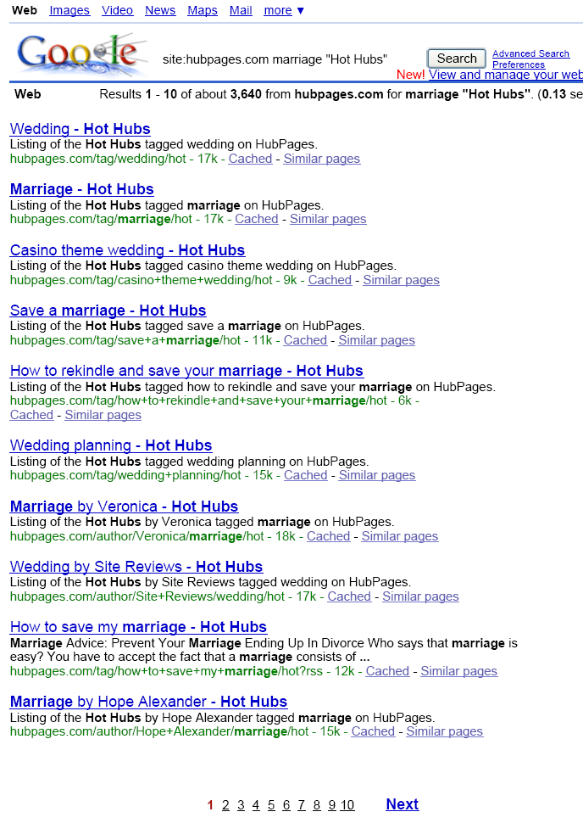

The search terms on the left of “– Hot Hubs” in the title are the tags or search terms that you want. Simply go through the search result pages and collect the tags for your Hub page.

2. You'll get free instant traffic from other HubPages with which you share tags.
This is a HubPage feature that very few people know about but that has the potential of generating a lot of traffic for you. If you share a tag with another HubPage Hub which is already ranked well in the search engines and getting traffic, your Hub will be featured in the related Hubs Section
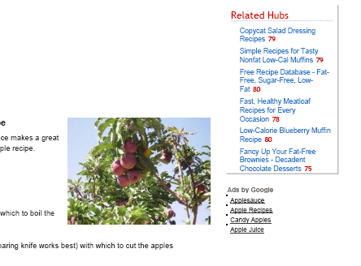
So if you discover a very popular Hub, just create a similar Hub and copy some of the tags from this Hub. Remember a lot of Hubs also get lots of traffic from other sources such as being featured on a high traffic news site.

In order for this to work well, you need to create hubs in sets and put as many tags (mostly from existing Tag Pages) as you can for each hub. I'm not sure about the maximum number of tags that HubPages allow but I've seen some Hubs with a lot of tags. I usually aim for about 40 tags on each Hub. If you put too many tags, your Hub may be flagged automatically by the HubPage system. You would have to remove some Tags and republish your Hub again to remove the flagging.

Another advantage to using this trick is that Google and other search engines will index your Hub faster because it will have links from pages that are already indexed in their search engines.

Using the Tag Page Traffic Generation Trick on Squidoo.

This strategy works in a similar way on Squidoo too. But you'll be getting better success with HubPages simply because they allow you to add more tags than Squidoo does. But you can overcome this by creating more lenses so that you can have more tags. I think the maximum number you can add on Squidoo is about 20 tags. So if you create 10 lenses, you can have links from 200 tag pages!

Create lenses in the normal way. Then do some searches on Google or any search engine that you're interested in for Tag Pages. You can also copy tags from any well ranked Squidoo lenses that you discover in the search engines.

All you have to do now is add all the tags from existing Tag Pages to your Squidoo lens. If the Tags are more than 20, create more lenses and add those tags. This is why it's a good idea to create lenses in groups of 3-5 or more so that you can use all the tags available.

Most of your traffic will come from Tag Pages and from related lenses links on other Squidoo Lenses.

To see examples of Tag Pages on Squidoo go to:

http://www.squidoo.com/tags/affiliate-marketing
http://www.squidoo.com/tags/love
http://www.squidoo.com/tags/treatment

Related Lenses links on Squidoo Lenses

You’ll see these links near the bottom right of each Squidoo lens. If your lens shares tags with another lens, it will be featured on the ‘More Great Lenses’ section. Copy some of the tags from popular lenses to start getting some of the traffic instantly.

The fastest way to get instant traffic and High PR links to your Squidoo lens is to add tags from tag pages that are already listed in the search engines. To find the tags, go to Google.com and enter the following in the search box:

site:www.squidoo.com "Squidoo : Tags" KEYWORD

Replace KEYWORD with your main keyword phrase. You’ll get a list of tag pages on Squidoo that are already indexed and ranked in the Google Search engine. Some of the pages are PR4’s and PR5’s.

For example, if you search for

site:www.squidoo.com "Squidoo : Tags" social bookmarking

on Google.com you’ll get:

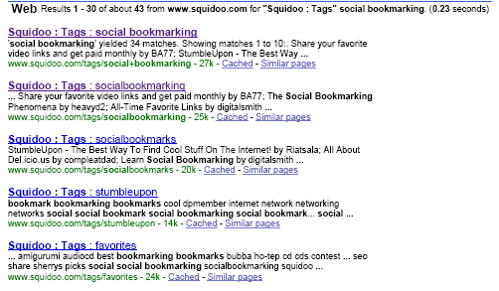

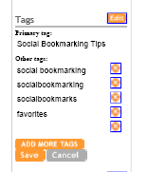
From the above you can see some of the tag pages about social bookmarking that are already listed in Google. Just add the tags: social bookmarking, socialbookmarking, social bookmarks, StumbleUpon, favourites, etc to your lens and you’ll instantly get your lens listed on these pages for free. At the time of writing the above tag pages were PR3’s. But I’ve seen lots tag pages with PR4’s and PR5’s.

Because a lot of lenses are linking to these tag pages, some of them are very well ranked in Google and MSN. This is where your instant traffic will come from because if you add a tag to your lens that corresponds to a highly ranked tag page, your lens will immediately start getting some of the traffic from that tag page.

Some tag pages are very well ranked in Google, MSN and Yahoo. You can find these tag pages on the first page of the search results. If you find a tag that corresponds to a highly ranked tag page, it can bring lots of free traffic to lens.

Recap:

So how do you get instant traffic for your Lens or Hub.

1. Create your Lens or Hub
2. Search Google or other search engine for tags using:
site:www.squidoo.com "Squidoo : Tags" KEYWORD
for Squidoo or site:HubPages.com KEYWORD "Hot Hubs"
for HubPages
where KEYWORD is your main keyword or phrase for your lens or hub
3. Make a list of all the tags from the tag pages listed in Google
4. Add the tags to your lens

General Tips:

- Write interesting Titles for your HubPages and Squidoo Lenses so that you can maximise the clicks.

- Always create Hubs and Lens in sets. This will increase the number of tags you can add to your pages and therefore increase the amount of traffic you can get.

- If you're promoting a niche product that has no existing lenses of hubs, look for related tags and add those in addition to your own from keyword research tools.

Resources:

Affiliate Programs:
Auction Ads – They’ll give you $25 just for signing up and you can promote just about any product that is sold on eBay. If you can’t find it on Clickbank, CJ, etc just do a search on eBay and use their URL converter to generate an affiliate link.
Clickbank – Very popular with internet marketers and great for promoting digital products. You can build a nice income writing articles on Squidoo, HubPages and Ezinearticles.com promoting Clickbank merchants.

Commission Junction – If you want to promote products and services from the Big Companies, CJ has them all.

Where to publish your articles:
HubPages.com
Squidoo.com
Ezinearticles.com
Blogger.com

Disclaimer: The information in this report is provided as is with no guarantees that you’ll achieve the same results. You may do better or worse but that’s beyond our control. This report is based on my own experience using Squidoo, HubPages and Google. Some people who read this report will get better results. Try to be one of them. By reading this report you agree that you will not use this information for anything illegal or to harm a website, persons or property.

